Project Management: Purchasing a Home
Name
Institution of Affiliation
Purchasing a Home
Purchasing a house is one of the largest expenses that an individual could incur in their lifetime. Most people have the notion that owning a home is an indispensable part of living the American Dream. It offers lots of social and financial benefits as well as risks. Therefore, it is a project that should be carefully planned and administered before implementation. Buying a home is a project may involve a considerable number of activities and must be carefully planned and executed. The cost and time of completion are predetermined during the planning process. to ensure success, the relevant tasks must be identified and time estimates made. The resources required in the project must be identified and appropriate budget prepared. Once the project is underway, monitoring and evaluation ought to be administered and necessary modifications or changes made. It is imperative to understand that the cost of buying a home entails more than just the purchase price. Therefore, one has to have enough money to cover both the initial expenses as well as the purchase price. This report is highlights the management of a project for purchasing a home.
This was a personal project and therefore the only organization involving was the real estate company that I consulted while looking for the appropriate house to buy. I used a realtor from the company to shop for houses in three cities that I picked to be ideal for me live there. Buying a home was an opportunity for me to settle down and develop a sense of belonging in a community. Besides, it was to offer a sense of personal satisfaction by having a place that I could share and enjoy with family and friends. It is an investment for the future with the value of the house set to increase over time (Guide, 2020). I could build on home equity as I pay the mortgage over the years. This is the current market value of the house minus the remaining mortgage balance. Therefore, the project was to be an addition into my wealth.
By implementing this project, I had to address the realities of home ownership such as ongoing mortgage costs and home upkeep. This is a large and long term financial responsibility with commitments to mortgage payments, utilities, insurance, taxes, and house maintenance. I would be responsible for all maintenance and repair costs as well as paying property taxes. Besides, by purchasing a house, it makes it harder because it would necessitates selling of the house first before moving and this could take time (Zhai & Peng, 2020). Money could be lost if the house is sold because it is barely a guarantee that the house value will increase upon buying.
Before implementing the home purchase project, it is imperative to determine the needed house features such as design, square footages, number of bedrooms, presence of garage, and fenced yard as well as the features of the neighborhood. There are a number of professionals necessary in facilitate the success of the project and these include mortgage lender, realtor, home inspector, and insurance agent. The mortgage lender offers the finances for the purpose of buying the home. Realtors are state-licensed professionals that represent home buyers or sellers in real estate transactions (Zhai & Peng, 2020). Home inspectors are licensed to inspect the home that a buyer wish to purchase. Insurance agents guide in purchasing the most appropriate coverage for the new home.
The various tasks for the project include brainstorming for the house features, establish the base requirements and budgets, planning and executing searches, offering the house price and acquiring the house, as well as budgeting and planning for future events. The appropriate approach to plan and schedule the home-buying project is the Gantt chart. This is a visual tool to schedule the project activities and monitor progress over time by making comparisons of the actual progress and expected project (Gray et al., 2008). The chart indicates the activities to be undertaken, their expected duration as well as when they will occur. By using the Gantt chart, the assessment of how long the project will take is made easy. The needed resources are determined and the order of how activities will be done is established. Besides, the chart help manages dependencies between tasks (Kivilä, Martinsuo, and Vuorinen, 2017). For instance, upon searching a house and identifying a suitable one, the down payment is made followed by acquisition and furnishing of the house. What follows is paying the home bills as well as planning for future events. The Gantt chart for the home buying project is demonstrated in figure 1 below.
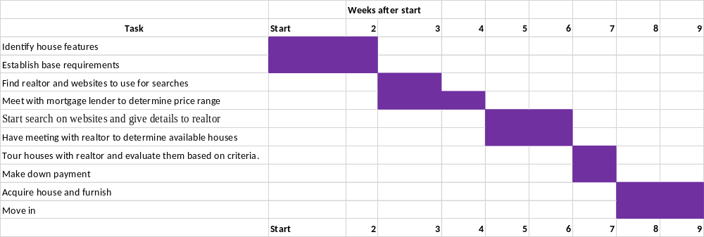
Figure 1: Gantt chart for purchasing a home
Apart from creating the Gantt chart for the project, it is imperative to develop a PERT (program evaluation and review technique) network diagram with the Critical Path (CP) identified. This helps in the planning and coordination of the project. It is a graphical display of the activities in the project and estimates the duration of the project (Stevenson & Ozgur, 2006). The diagram indicates the tasks that are most critical for timely project completion and success and enable the project manager to establish how long a task can be delayed without causing havoc in the project. Figure 2 below shows the PERT diagram together with the critical path for the house-buying project.
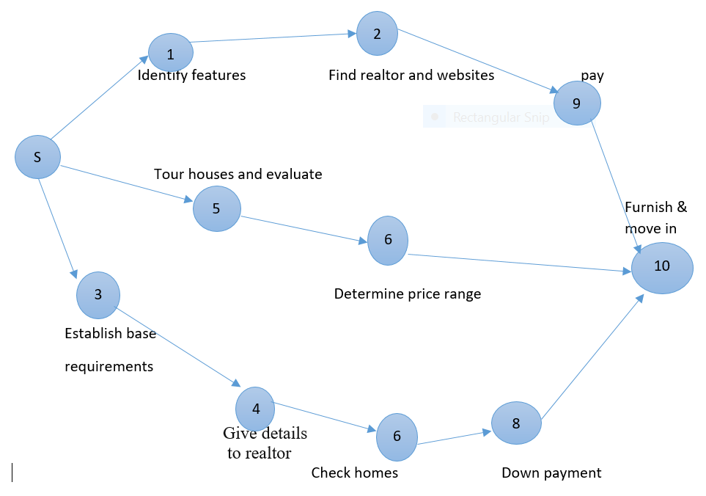
Figure 2: PERT diagram for home purchase project
The critical path is represented by the S-3-4-6-8-10 path. It is the path with the longest completion time. If there are any delays in this path, there will be corresponding delays in the completion of the house-purchase project. Initiatives to reduce the project completion time must be directed at the critical path (Schwalbe, 2009). The other paths that are shorter than the critical path can experience delays without affecting the overall project completion time as long as the total time is not above the time required in the critical path (Collier, 2009). This time allowance is the slack time and is the difference in the time of any given path and that of the critical path. The length of the critical path is 9 weeks. The length of the other two paths is 5 weeks and 6 weeks making the slack time to be 4 weeks and 3 weeks respectively.
Slack time = length of the critical path – length of alternative path
The critical path has zero slack time and delays would cause major problems in the project’s completion time.
The actual time of the project is subject to variation and therefore the estimates can only be probabilistic. This approach involves three estimates: optimistic time (t_{o}), pessimistic time (t_{p}), and most probable time (t_{m}). This time estimates are made by those with knowledge about the project (Radujković and Sjekavica, 2017) This estimates for the home-purchase project are 6 weeks, 10 weeks, and 8 weeks respectively. The expected time of completion of the project t_{e} is a weighted average of the three estimates done by the formula below.
T_{e} = $\frac{t_{0}+t_{p}+{4t}_{m}}{6}$
= $\frac{6+10+4(8)}{6}$ = 8 weeks
Variance is found by the formula:
σ² = [$\frac{t_{p}-t_{o})}{6}]$²
= $[\frac{10-6}{6}$]² = 0.4
Standard deviation = $\sqrt{σ^{2}}$ = $\sqrt{0.4}$
= 0.7
The network diagrams for the various paths are demonstrated in figure 3 below.
10
9
2
1
S

10
7
5
S

10
8
6
4
3
S

The probabilities for the various activity paths can then be calculated using the formula:
z = $\frac{specified time-Path mean}{Path stand deviation}$
For S-1-2-9-10 path:
= $\frac{6-8}{0.7}$ = 2.857, which is a probability value of 0.998
For S-5-7-10 path:
= $\frac{5-8}{0.7}$ , which is a probability value of 0.999
For S-3-4-6-8-10 path:
= $\frac{8-8}{0.7}$ = 1
Therefore, the path with the highest probability is the critical path. The project may not be completed until all the necessary activities are addressed. Hence, the critical path cannot guarantee that it is the maximum time for project completion. Most of the paths have probabilities of occurring that is at least 99 percent. Thus, it is feasible to focus on the path with the least completion time, which is S-5-7-10. Apart from time, the budget constraints must also be considered especially in the project of buying a house where they could a number of hidden costs. Table 1 below shows the dynamics of the project’s budget.
Table 1:Hypothetical budget for the project
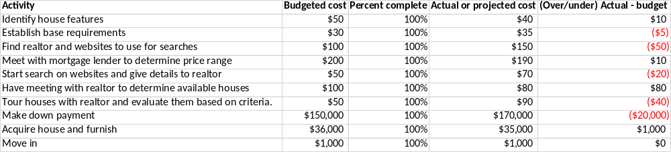
These budget is derived from an estimation of the costs that could be involved in addressing the various activities for the project. For instance, the largest expense would be the down payment for the house while furnishing the house would also take a considerable amount. Establishing base requirements for the house would be a minimal expense followed by others such as identification of the house features and travelling around to check the houses based on the predetermined criteria.
Project activities could be crashed to reduce the time spent on the project or free resources for use in other projects. To make a rational decision on the activity that can be crashed, it is imperative to have information on the regular time and crash time estimates for each activity, regular costs and crash cost estimates for each task, and a list of activities that are in critical path (Stevenson, 2014). The appropriate activities for crashing are those in the critical path because crashing tasks on other paths may not have any significant effect on the project duration. Activities are crashed based on their costs with the lowest costs in the critical paths being used. The activity that has the least cost in the critical path is establishing base requirements for the house to be purchased with a budgeted cost of $30 dollars. Crashing this activity would reduce the project cost by $30 and project duration by 2 weeks. This is a significant benefit with minimal effect on the project’s success.
References
Collier, D. A., Evans, J. R., & Stevenson, W. J. (2009). Operations management. Cengage Learning.
Gray, R. M., Cook, M. B., Natera, M. T., Inglis, M. M., & Dodge, M. L. (2008). Project Management: The. In Managerial Process”, McGraw-Hill.
Guide, G. P. (2020). Buying Property in United States| How to Buy a House in United States.
Kivilä, J., Martinsuo, M., & Vuorinen, L. (2017). Sustainable project management through project control in infrastructure projects. International Journal of Project Management, 35(6), 1167-1183.
Radujković, M., & Sjekavica, M. (2017). Project management success factors. Procedia engineering, 196, 607-615.
Stevenson, W. J. (2014). Operations management. McGraw-Hill Education.
Stevenson, W. J., & Ozgur, C. (2006). Introduction to management science with spreadsheets and student CD. McGraw-Hill, Inc.
Schwalbe, K. (2009). Introduction to project management. Boston: Course Technology Cengage Learning.
Zhai, W., & Peng, Z. R. (2020). Where to buy a house in the United States amid COVID-19? Environment and Planning A: Economy and Space, 0308518X20946041.

